**Thinking programmatically:**

Pseudocode, writing out your program in plain English rather than a programmatic language. So that you won’t be distracted by syntax.

Comments in Javascript:

Multiple line comments: /*

Single line comments: //

Write pseudocode in comments, when you are planning, then replace them with actual code once you have confirmed the code.

Example of pseudocode:

// When the button is clicked

// If ring is not on Frodo's finger

// Put ring on Frodo.

// Make Frodo disappear.

// If ring is on Frodo's finger

// Take ring off of Frodo.

// Make Frodo appear.

**Introduction to Javascript**

We use variables to temporary store data in order to use them later.

1. Declaring Variables
2. Assigning Values to variables
3. Variable Syntax
   1. Name variables using the camelCase format, as shown: camelCase. uniqueName. javaScript. camelsAreAwesome.
   2. Javascript is **case-sensitive**
   3. End statements with a semicolon;
4. Reassigning Variables
   1. Declare -> var age = 46;
   2. Reassign -> age = 22;

**Data Types**

Displaying Variables on HTML

document.getElementById(“<HTML Tag>”).innerHTML = <variable name>;

Use “typeof” to check datatype.

typeof true

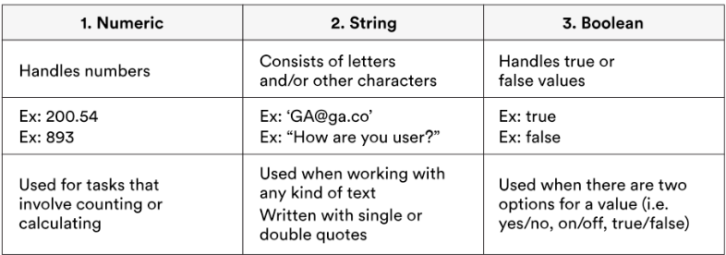typeof “John Doe”

1. Integer
2. Floats (Decimals)

**Expressions and Evaluations**

Expressions combination of data and operators which produces a value.

Evaluation is the process of reducing an **expression** into a single value.

Adding quotation marks makes datatype a string.

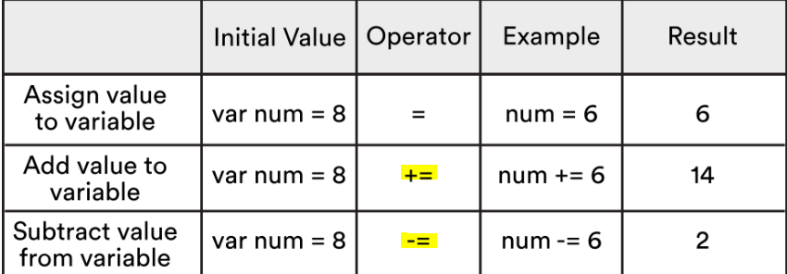

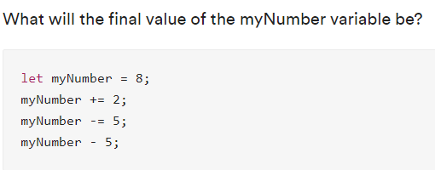

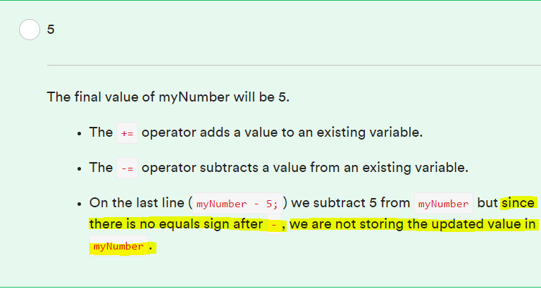

**Where to place JavaScript code?**

Place Javascript code within the <script> tag, at the very end of the <body> element (just before </body>). This makes sure all the HTML elements are loaded so that Javascript can work on them.

Relative Address can be used, the reference point being the location of the HTML file. Use Absolute Address if file is located before the HTML file (in the parent directory).

Eg.

<script type="text/javascript" src="C:\Users\wzlian.2014\fundamentals\wdi-fundamentals-memorygame\memory_game\js\main"></script>

Press F12 to open Developer Tools in browser. This is where you can see the HTML code and Console in the browser.

**Control Flow**

Control Flow is the flow of the computer’s action through a program. Conditionals and loops vary the flow. Conditionals are like forks on the road, loops are like running tracks.

Conditionals are used for decision making, and loops are used for repeated behaviours.